2015

U5-U6
Academy
Coaches Manual

Contents Page

Page # |  | Contents
1 |  | Cover Sheet
2 |  | Contents Page
3 |  | Introductions & Expectations
4-5 |  | Coaching Session Make Up
6-7 |  | Important information
8 |  | Field Set Up & Take Down
9 |  | Field Layout
10-11 |  | 10 Week Coaching Syllabus
12 |  | Coaching Game Contents Page
13-22 |  | Coaching Games
23 |  | Blank 24-7 Coaching Template  (Be creative and design your own drill)

U5-U6 Soccer

The Introductory Phase
60-minute session that is fun, enjoyable and varied
- The introductory stage of development focuses primarily on mastery of the ball and understanding the 1v1. The main emphasis should be when “we” have the ball (offense). There will be little emphasis on coaching when “they” have the ball (defense) with the main goal being to get the ball back.
- The main objective within the curriculum is to develop a passion for the game of soccer and mold individual soccer personalities.

Expectations of U5-U6 Coaches
  - Emphasize having fun, but playing 100% while developing players who have respect toward the sport, teammates, coaches and opponents. Players will be encouraged to have “confidence” with the ball and to make things happen with skill - “not be afraid to make mistakes”.
- Sessions almost 90% focused on individual technique. The 10% of Strategy and tactics will be based on the individual and very basic in both “we” have the ball (offense) and “they” have the ball (defence).
- Teach psychomotor skills and general coordination both with and without the ball and teach all necessary movements needed for technical skill development.

Coaching Session
Arrive early to your session to set up before players arrive and make sure you are dressed appropriately. A typical 60-minute practice session should include, with breaks for water, the following:
- Phase 1: Warm up players have 300 touches of the ball– 15 minutes (includes ball manipulation, turns, moves, speed & agility)
- Phase 2: Topic including fun game – 10 minutes
- Phase 3: Opposed practices – 1v1 - 10 minutes
- Phase 4: Small Sided Game (SSG) – 20 minutes (2 x 10 minute games of 3v3, or 4v4)
- Phase 5: Reflect – 2-3 minutes
Phase 1 This is probably the most important phase, as it will form the basis of a player’s soccer foundation as they learn the fundamentals both with and without a ball. The 300 will include a variety of touches on the ball, as well as some ladder work to help promote the Physical development (i.e. balance, coordination, speed)
Phase 2 This is where new ideas can be explained and practiced with a fun game to help the players enjoy their learning experience.
Phase 3 This is where the goals come into play and the players get a chance to go to goal and enjoy the feeling of scoring a goal in 1 v 1 situation. Players can be challenged here if to easy, just as they can maximise their chances to score goals and experience the joy that this brings to both them and their parents.
Note Phase 2 & 3 can be combined in the same session
Phase 4 Some vary basic team concepts for players as they now have other players to pass to and decisions to make of when to pass or move with the ball. Very basic at this age but allows coaches to challenge players of all abilities.
- Small Sided Game’s main objective is to keep players active and engaged. Regular soccer rules are relaxed, and restarts controlled by coaches. Make sure you have multiple soccer balls by your side, employ the help of parents or assistant coaches to get the ball back to you, so you have a constant supply. This way you can dictate who gets the ball to start, allowing players who may not be that involved to start, the opportunity to get the ball on a consistent basis.
- No Goalkeepers or guarding the goal, and play 3v3 or 4v4
- During the game teams will sometimes be uneven. This is a common occurrence and easily rectified. Here are some simple hints to help prevent if not rectify such occurrences: -

- Speak to the other coach before your start and identify the field you are placing stronger players on
- Do not be afraid to move players around during the game
- Players can play for either team, although ideally you want to keep to your team, however if moving a player around helps even the teams, then do it
- Do not take players from the game, instead be creative in ways to allow that player to help other players, i.e. 5 touches then a pass, or they can only score every other goal, or with their weaker foot
Phase 5 A very short recap on what you did, make they had fun and a cheer to finish the day
There is nothing better than the feeling of seeing the ball hit the back of the net, for both players and parents. The bow net goal, shown below, allows players to experience the fun of seeing the ball hit the back of the net. They can be set up and taken down in less than two minutes. Please do not let the players lean or hang of the goals. When putting away please make sure that you have all four poles in the bag and the nets are not tangled, as this increases set up time the following week.
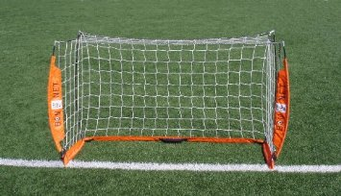
Important Information

Coaches’ Equipment: All coaches should have their red MSC coaching shirt. If not please contact Mark Nutter with your size. It is important you a wear your shirt at training so players and parents can identify you as a coach. Montclair has a sponsorship deal with adidas, so any other adidas apparel you may have is desired but not required. Make sure what you wear is appropriate and comfortable, if black and adidas then even better…

Players’ Equipment: Player’s equipment shall consist of shirts, shorts, socks, shoes and shin guards. Soccer shoes are recommended. Tennis shoes are allowed. Football and baseball cleats are not allowed due to the extra toe stud. No hard shoes or shoes with metal or other dangerous appendages are allowed. No player is allowed to practice or play without shin guards. Socks must completely cover shin guards. Shin guards are worn under the socks. Shirts should be tucked in. No orthopedic (even if covered) or hard casts are allowed.

Warm Up: 300 touches may sound like a lot, and for this age group you will obviously not get the players to count, (may be ask a parent to count a few times just to see how many players are getting). The key is that we give players the opportunity to maximize their touches on the ball and as the weeks go by, new skills can be incorporated into the warm up.

Team Snap: MSC will provide all teams with access to team snap. Either set this up or pass this responsibility to a parent and ask they to set up and maintain. If used properly, it will allow the coach to communicate to the team and see how many players you are expecting for game day. It is also useful for informing players of extra events, such as training, photo day and team get together. For more help on this please contact Mark Nutter.

Snacks: All kids love snacks but be aware more and more children are allergic to certain foods, and therefore if you do have parents bring snacks please make sure that your are aware of any allergies your players may have, or make sure a parent is in attendance before a player receives their snack.

Positive Coaching Alliance – (PCA): Montclair strongly believes in the benefits of PCA and has multiple courses every year for all levels of members. Check out the MSC website for information on courses both parents and coaches should attend. Place this information on team snap as well as a link to the PCA website

What if it Rains In the event of bad weather, MSC will look to send out an e-mail to all players and coaches notifying them of field closures. Again if this happens please make sure to update team snap and send out any additional notifications so we can avoid players and parents making the unnecessary journey to the field.

It may be possible to makeup one rain out day at the end of the fall season and coaches will be notified in advance if this is necessary.

Getting to Know the Parents Although all players will have a parent or guardian at the field, it will help the season if you make the effort early to get to know the person(s) who attends the session with the player. This could be their first experience of soccer and a friendly face, smile and hello from the person who is going to be teaching their child, will help ease any concern they had of signing up for soccer. Hopefully you would have had time prior to the start to e-mail and introduce yourself, but putting a face to an e-mail is much more personal and friendly. Who knows, you could spend many more years with some of these people, so a good first impression really helps.

The 24-7 Staff are There to Help Finally, the 24-7 staff are there to help you and a useful resource for you to use, They are not there to take over your session, but help and assist when you need it. Like wise any questions during the week, then do not hesitate to e-mail coach Mark.

In Case of an Emergency Every player should have a parent with them at the field, however just in case keep a copy of player contact information handy. Team Snap will be handy for this if you have access on your cell phone.

A 1st aid kit will be available at the field

Field Set Up & Take Down

Field Set Up: All sessions will be take place at Merritt college field “A”. The 24-7 trainer in charge will arrive to open the storage locker, where all the equipment is held, and then the field will be set up by the first U6 group that attends.

The fields will be set up according to the diagram on page 9. All 12 fields must be set up at the start of the day, even if fields 6 & 12 are not needed for that session. For some sessions these may be spare due to a lack of teams that day.

Field take Down: Please make sure that everything is packed away neatly from your field before you leave. Once goals, balls and coaching equipment have been packed away, please return them to the shed. The bag of balls will be placed at the back of the shed in the right hand corner on the top two racks. The goals will be placed on the second shelf on the rack to the right as you walk in. Ladders will be placed on the left hand side, second shelf down with the other ladders.

Coaching Equipment: All necessary equipment will be at the field, kept in the storage locker. Please make sure that the equipment is used responsibly and that at the end of he session, regardless of if you are not the group packing away, all the equipment is packed away and stored by one of the goals on the field you coached on, ready for the next coach. Please leave the coach area and equipment in a way you would wish to find it. If you are missing any coaching equipment, then please notify the 24-7 at the field and they will report and a replacement item will be ordered where appropriate.

There are 6 bags of equipment for the U5/U6 program. Each bag is marked with the fields it is to be used with. i.e. bag 1 is marked Field 1 & 2. It will contain at least 14 soccer balls, 15 bibs of the same colour, and cones to mark your area. The soccer balls are also marked with the lowest number of the field you are using. So bag 1 soccer balls are marked U6 #1. Bag 2 is for fields 3 & 4 so soccer balls are marked U6 # 3 and so on. Please make sure at the end of your practise that you have 15 bibs and 14 soccer balls in the bag ready for the next group. All bibs are a different colour for each field so easier to identify players on your team

Trainer Lead Demo: Prior to the start of your session, the 24-7 staff member will go over the topic for the day, including any turns, moves or ball manipulation you will working on, and then go through a fun game demo for you observe and play with the player later. Again do not hesitate to ask questions and use the coaching staff to help.

Ladder Work – (Speed – Agility - Quickness): Coaches will have access to two ladders set up in a specific area to use with your players at any time during the first 40 minutes of practice. Please do not use during game time, and make sure players are supervised during the activity. Coordination is a key element to a successful soccer player and starting players with the very basic ladder drills is a perfect, fun way to get a player working on the agility and coordination required to play soccer.

U5-U6 Field Layout Merritt College

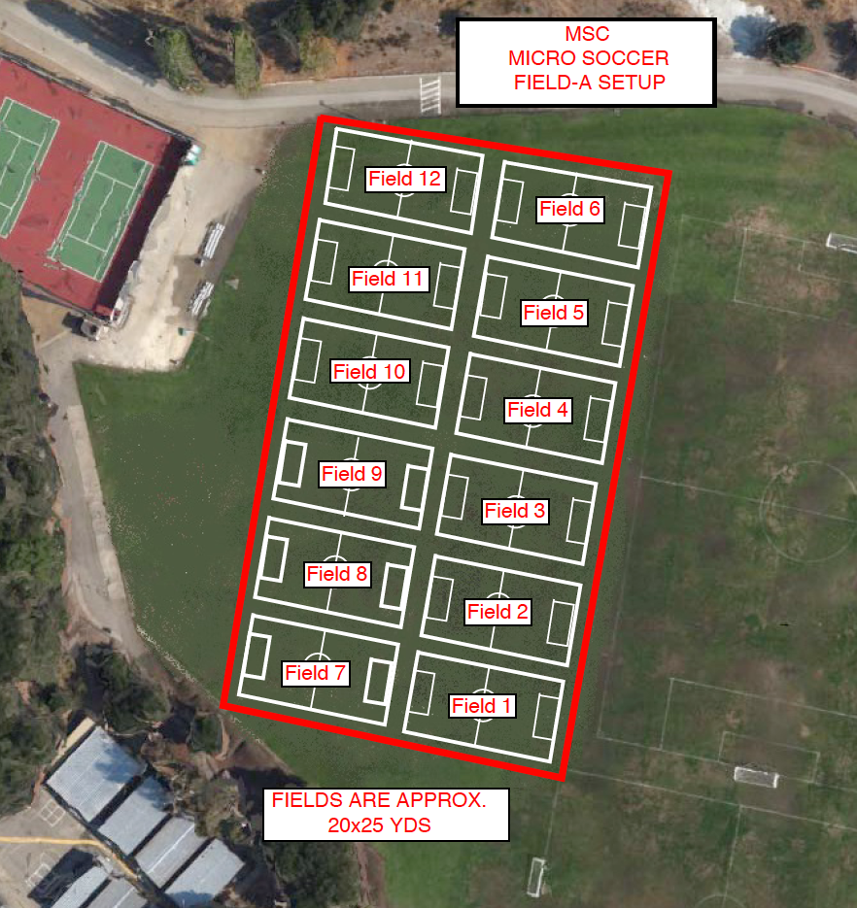

10-Week Coaching Syllabus
U5 Topics – Skills – Turns/Moves

For the U5 age group the following curriculum has been put together to allow coaches to structure their session to allow for a 2-week cycle to introduce a new topic, skill and turn/move. The first session will allow both player and coach to familiarize themselves with the exercises, and the second will allow for more repetitions as players and coaches are more comfortable in the delivery and execution of each topic.

Any issues during the first week you can seek help and advice form the coaching staff and make any changes you feel would benefit the session the following week.

Week # | Topic | U5 Skill | U5 Turn/ Moves
1 | Passing Technique | Toe Taps | Stop Turn
2 | Passing Refresh | Toe Taps Refresh | Stop Turn Refresh
3 | Controlling Technique | Boxes | Drag Back
4 | Controlling Refresh | Boxes Refresh | Drag Back Refresh
5 | Dribbling Technique | Walk The Puppy | Step Over
6 | Dribbling Refresh | Walk The Puppy Refresh | Step Over Refresh
7 | Shooting Technique | Toxing | Matthews Move
8 | Shooting Refresh | Toxing Refresh | Matthews Refresh
9 | Review Week | Refresh All Skills | Refresh All Turns/Moves
10 | Street Soccer | Street Soccer | Street Soccer

U6 Topics – Skills – Turns/Moves

For the U6 age group you will start by going over the drills the players will be learning at U5, and then move into slightly more challenging skills, turns/moves. The same two-week cycle allows players and coaches to work on these skills, hopefully allowing more success with each topic.

Again, as U5, any issues during the first week you can seek help and advice form the coaching staff and make any changes you feel would benefit the session the following week.

Week # | Topic | U6 Skill | U6 Turn/Moves
1 | Passing Technique | Refresh All U5 Skills | Refresh All U5 Turns/Moves
2 | Passing Refresh | Refresh All U5 Skills | Refresh All U5 Turns/Moves
3 | Controlling Technique | Rest Ball On Foot | Outside Hook
4 | Controlling Refresh | Rest Ball On Foot Refresh | Outside Hook Refresh
5 | Dribbling Technique | Flamingo | Double Scissors Move
6 | Dribbling Refresh | Flamingo Refresh | Double Scissors Refresh
7 | Shooting Technique | Push Pull | Cruyff Turn
8 | Shooting Refresh | Push Pull Refresh | Cruyff Turn Refresh
9 | Review Week | Refresh All Turns/Moves | Refresh All Turns
10 | Street Soccer | Street Soccer | Street Soccer

You can use any games you like to work on the skills for U5-U6, not just the one suggested in the table above, as many of the games can be tailored to meet the needs of the topic for the day.

Remember the mind works like a parachute, “best when open”, so do not be afraid to try different drills, and even change them if you think it will work. Also watch the trainers’ and other coaches around you.

“A good coach is a good thief, and will steal any ideas they can to help improve their coaching knowledge”

Below are 8 session plans that consist of a warm up activity, (here we would like you to encourage the players to touch the ball at least 300 times); it also includes two fun games to help you with your topic for the week.

The 9th session is a review week session with more ideas for games, however you can use the games the players enjoyed most from previous weeks, to review all the topics.

The 10th session gives a few more game ideas, but week 10 can be used to play all the time, as many 3v3 or 4v4 games as you can. Mix teams and players and finish with an hour of playing. As mentioned before many of the games can be used for a variety of topics, so have fun exploring and challenging both yourself as a coach, and the young players around you.

Coaching Games

Topic & Page # | Game # | Games
Basic Passing Technique  # 13 | 1  2  3 | - Simon Says  - Tin Can Alley  - Battleships
Basic Passing Technique - Refresh  # 14 | 4  5  6 | - Network Game  - Marbles  - Gate Game
Basic Controlling Technique  # 15 | 7  8  9 | - Dirty Boots  - Traffic Lights  - Relays
Basic Controlling Technique - Refresh  # 16 | 10  11  12 | - Simon Says  - Gate Game  - Trash Can Soccer
Basic Dribbling Technique  # 17 | 13  14  15 | - Body Parts  - Stepping Stones  - Shark Tales
Basic Dribbling Technique - Refresh  # 18 | 16  17  18 | - Count a ball  - Hooked  - Top Gun
Basic Shooting Technique  # 19 | 19  20  21 | - Dirty Boots  - Tin Can Alley  - 2 Pots In
Basic Shooting Technique - Refresh  # 20 | 22  23  24 | - Network Game  - Top Gun  - Trash Can Soccer
Refresh All Topics  # 21 | 25  26  27 | - Countryside  - Traffic Lights  - Battleships
Street Soccer  # 22 | 28  29  30 | - Fire & Ice  - Scooby Doo  - Trash Can Soccer

